Model:
Smart Power gateway:
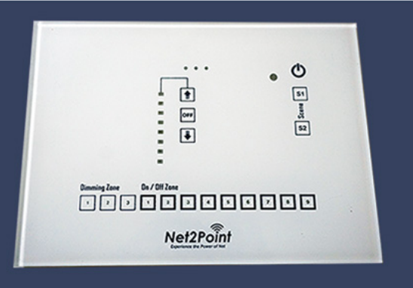
Net2Point WiFi Home Automation System contains IoT POWER AUTOMATION control system & mobile apps for controlling your lights without changing your existing wiring. It can be authorized on more than one mobile to control your electricity to lights and other electrical devices. It save your energy bill in long term and give complete return the value of investment.
Mobile App screenshots:
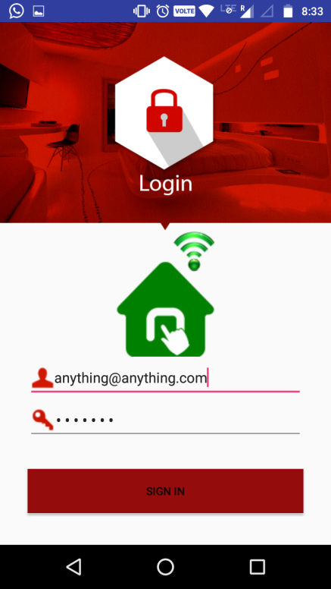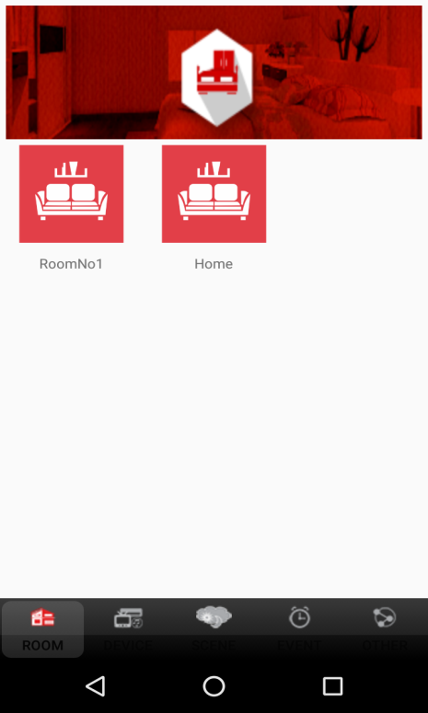
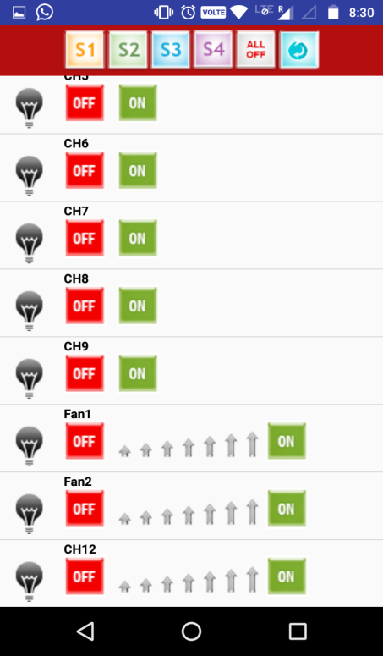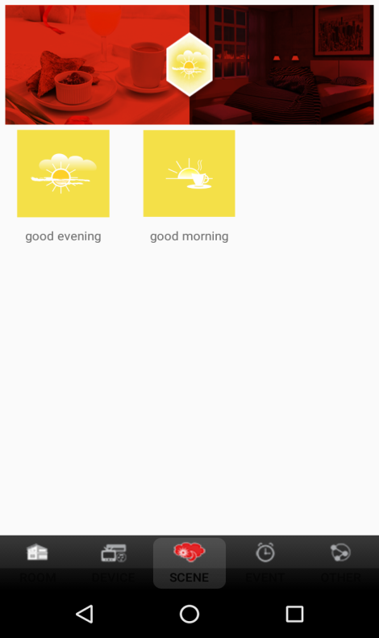
Features:
- Control more than 200 nodes
- Power automation on mobile with prescheduled
- Design your own digital mobile menu for power
- Online Control Panel for Customers & Partners
- 3 Years warranty

